How to Easily Download and Install Office 365 on your Home Computer.
Your Office 365 subscription through the Niagara Falls City School District allows you a number of free installs on your home devices as well.
To install the Office 365 is a relatively easy process.
- To get started - navigate to: https://login.microsoftonline.com
and login.
Username - windowsusername@nfschools.net (How you log on to
the server at school in the morning and add “@nfschools.net”. The Username could be the same as email but not necessarily. Some people have a middle initial in their email but not in their username and vice versa
Password is your password to log on to the server at school.
(not your email password unless they are the same)
- 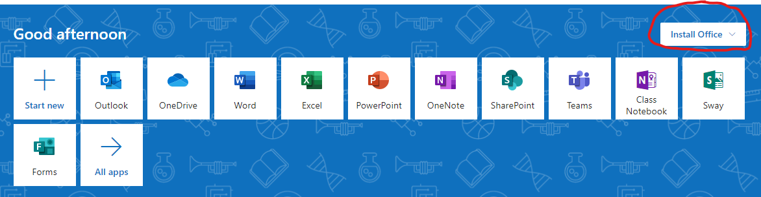
You should see this in your browser. Note the “Install Office” at the right.

- Click on Install Office and this appears. Select the top one.
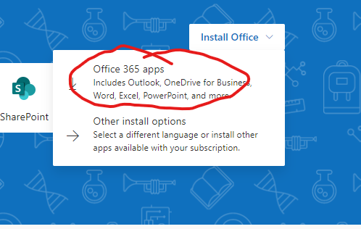
- 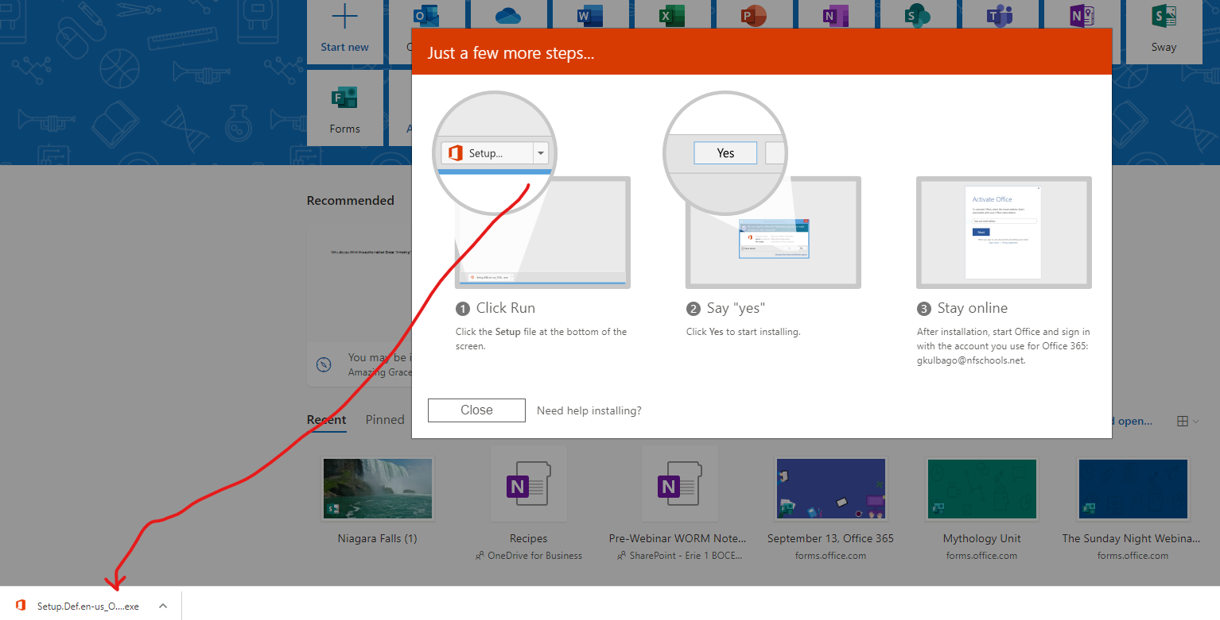
A short program will download. Click on the program at the bottom of the page, follow the easy instructions and office will install. It may take some time depending on the computer you have.

- If you have a phone or pad you wish to install the Office apps on, go to the app store and search for “Microsoft Office.” It will load an app that has Word, Excel and all the tools.

- The first time you use the program on your personal devices, you may be asked to log in using the same login you used to get to the online site at the top of this page.

- Any questions, please email Gene at gkulbago@nfschools.net or Roger
at rcarroll@nfschools.net.

